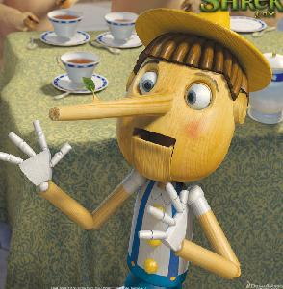
Pinocchio had a habit of telling lies. Each time he told a lie, his nose would grow. One morning while working at his father’s shop, Pinocchio decided to see just how long he could make his nose. He measured his nose at its original length. It was 4 cm. Then he yelled out, “Dogs make the best brain surgeons!” His nose grew 3 cm. He shouted, “Chocolate is the best toothpaste!” Again his nose grew 3 cm long. Next he yelled 20 and 20 makes 100.” His nose grew another 3 cm.
After he had told 15 lies, how long was his nose?

